Press Release For immediate dissemination
Tropical Agro Fortifies Farmer Solutions Portfolio for Comprehensive Support
New Product Line up Unveiled to Supercharge 2024 Kharif Cropping Season

Chennai, April 23, 2024: Tropical Agrosystem (India) Pvt. Ltd., a leader in the Indian agricultural sector, is proud to unveil its latest suite of farming solutions meticulously tailored for the upcoming 2024 Kharif cropping season. With a resolute dedication to tackling the dynamic challenges of agriculture, the company has fortified its product portfolio with 16 new offerings, covering the gamut of farming practices from seed treatment to post-harvest care.
Commenting on this milestone, Mr. V. K. Jhaver, Founder of Tropical Agrosystem (India) Pvt. Ltd., expressed the company's commitment to empowering farmers, stating, " We are steadfast in our mission to equip farmers with advanced technological formulations to effectively manage crop-related issues such as pests, diseases, and soil deficiencies. Indian farmers deserve access to top-tier farming solutions, which is why, through our innovation labs and dedicated product teams, we continuously strive to develop new solutions to enhance outcomes for major crops and fortify the future of farming."
Echoing this sentiment, Mr. Mohan Kumar, President of Tropical Agrosystem (India) Pvt. Ltd., emphasized the profound impact of these initiatives on modern farming practices. "Aligned with our purpose statement, these efforts are poised to safeguard and nurture crops thereby enhancing productivity and profitability for farmers. Our products are engineered to cover challenges across diverse crop ranges from Black gram, Chillies, Cumin, Potato, Paddy, Tomato, Wheat, Maize, Cotton, Bengal gram, Cabbage, Groundnut, Pigeon Pea, Soyabean, Sugarcane, to Tea and more. Furthermore, our enhanced collaborations with esteemed Indian and global entities will usher in cutting-edge agri-tech solutions crucial for the agriculture of tomorrow," he added.
The newly unveiled range comprises a diverse array of insecticides, herbicides, fungicides, and biological products, catering to the evolving needs of the Indian farming community. This strategic expansion mirrors Tropical Agrosystem's unwavering dedication to driving innovation and fostering sustainable agricultural practices, ultimately contributing to the prosperity of farmers and the resilience of India's agricultural landscape.
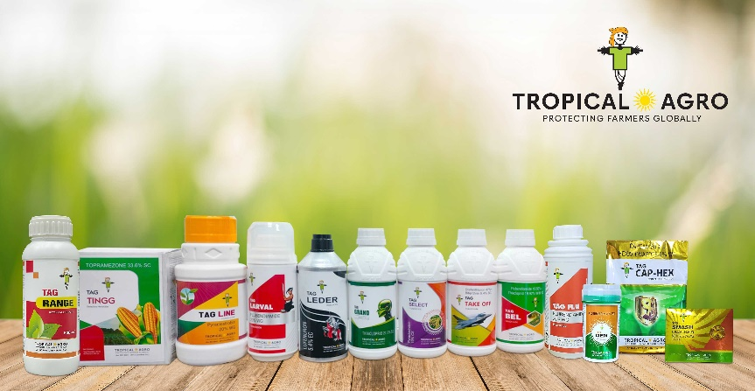

Tropical Agro upholds an unwavering commitment to excellence, ensuring all products adhere to international standards and are safe for end-users when used as recommended. Developed following rigorous assessments by agronomic experts, these products are engineered to enhance efficiency and deliver superior performance when applied to crops. They are designed to be user-friendly, economically viable, and resource-efficient.
Moreover, the company has ingrained a culture of product stewardship into its operations to minimize environmental impact. This commitment spans the entire product lifecycle, from research and development through production, marketing, customer usage, and disposal, ensuring responsible practices at every stage.

About Tropical Agrosystem (India) Pvt. Ltd.
Tropical Agro is a pioneer & a leader in the Indian crop protection & plant nutrition industry, both in the Chemical & Organic segments. Part of The Jhaver group, the company combines its rich heritage with a spirit of determination to improve the lives of farming communities and promotes responsible as well as conscious farming.
The company is counted among India’s Top 5 brands in the agri space and has an effective farm-to-consumer value chain of more than 8 crore farmers, who form our core customer base, 20000 distributors & retailers, 4000+ field assistants, and 1100 employees across all agro-climatic zones in the country. The company’s group consolidated turnover positions us 2nd among indigenous Indian agri brands
Driven by the commitment to shape the future of agri-farming and to meet the global challenges of food security, safety, and preservation of soil health; the company offers the widest range of full-spectrum agricultural solutions. Over 300 solutions have been so far curated to meet the needs of the Indian farmer. These products are developed at our strategically located 7 state-of-the-art manufacturing units & the 3 R&D hubs.
Visit us at: www.tropicalagro.in
Our social media channels:

For further enquiries, please contact:
Ms. Chandrika Rodrigues
General Manager - PR & Communications,
Tropical Agrosystem (India) Pvt. Ltd.
72, Marshalls Road, Egmore,
Chennai –600 008. Tamil Nadu, India.
Phone: +91 9500219262
Email: chandrika.v@tropicalagro.com

